Build Your Virtual Network Lab

Student Name: Arr Domingo
Course / Section: CYBR3090 – Cyberthreat Intelligence / O01, O02.1252
Instructor: Sam El-Awour
Date: January 19, 2026

Table of Contents
1.0 Introduction 1
2.0 Devices Used 1
3.0 Step-by-Step Rebuild Guide 1
3.1 Download “vhdx” file and unzip (using 7zip) 1
3.2 Set-up Hyper-V in your machine 2
3.3 Create Virtual Machine in Hyper-V Manager 7
3.4 Enable nested virtualization 13
3.5 Start the new virtual machine 14

1.0 Introduction
This document is about building the virtual machines (VMs) for hands-on cybersecurity training in a simulated real-world environment. The main tools used in this lab is Hyper-V, which is a virtualization software developed by Microsoft, allowing to create and run virtual machines (VMs) on x86-64 systems running Windows. Each virtual machine acts like a complete computer, running an operating system and applications, providing a flexible and efficient way to use hardware resources. Additionally, local computer must have a minimum specification of Intel i7 with 16 GB RAM (32 GB RAM is recommended for better experience).

2.0 Devices Used

3.0 Step-by-Step Rebuild Guide

3.1 Download “vhdx” file and unzip (using 7zip)
- In the Brightspace, go to “Resources” under “Build Your Virtual Network Lab”.
- Notice that there are 12 VHDX (Virtual Hard Disk Extended) files, download those 12 files one-by-one (depending on your internet connection, this would take time).
- Keep the "File name" and "Save as type", then choose the location where you want to save the VHDX files.
- Click "Save". Repeat until you get all 12 VHDX files.
- If your machine does not have 7zip File Manager, download the app.
- Open 7zip File Manager app.
- Where you see a folder icon, paste the location of those 12 VHDX files.
- Highlight the first (.001) VHDX file.
- Click "Extract".
- Choose a location where you want to extract.
- Click "OK". When ask for password, it is “CYBR3090!!” (without the double quotation). Depending on your machine, the extract process takes some time.

3.2 Set-up Hyper-V in your machine
To be able to run Hyper-V on your machine, version of Windows 11 must be Education or Pro. If your machine is Windows 11 Home, follow below instructions to upgrade:
- First, check the version of your Windows 11. Click Windows and type “winver”.
- If the version of Windows 11 is Home, follow the next steps to upgrade the version to Education or Pro. Otherwise, no action is required.
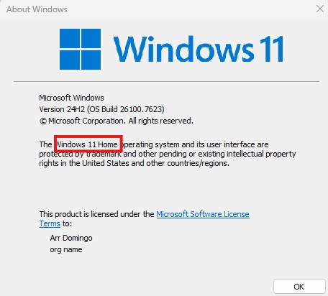
Figure 1. Check the version of Windows 11.
- Go to https://portal.azure.com/#home
- Under “Azure service”, click “Education”. If “Education” doesn’t show, click “More services” and search for “Education”.
- On the left panel, expand “Learning resources” and click “Software”.
- Search for Windows 11 and click “Windows 11 Education, version 25H2”.
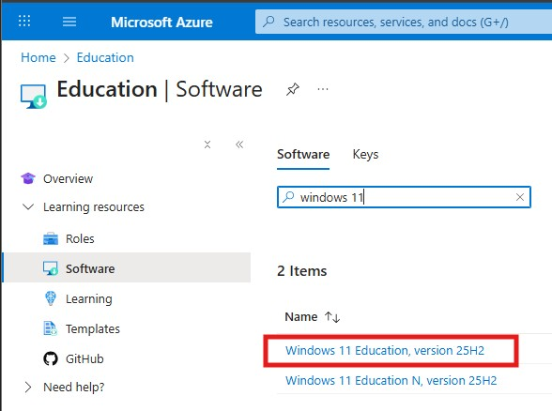
Figure 2. Install Windows 11 Education
- Click “View Key” button, take note and save the “Product key”.
- Click Windows and go to “System”.
- Scroll down and click “Product key and activation”.
- Click “Change” in Change product key.
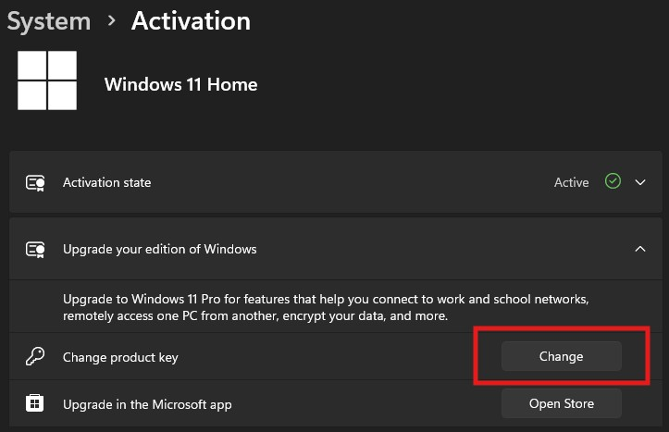
Figure 3. Change product key.
- Paste the Product key and click Next.
- When ask to “Upgrade your edition of Windows”, make sure to save all your works and click “Start”. This will restart your machine and will take some time.
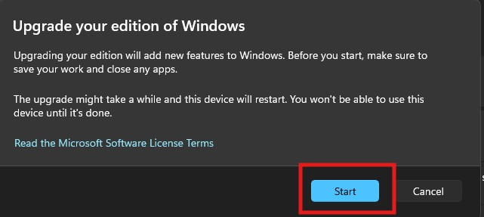
Figure 4. Click "Start" to upgrade Windows 11.
- After restarting, check the version of Windows 11. Click Windows and type “winver”. By this time, Windows 11 must be Education.
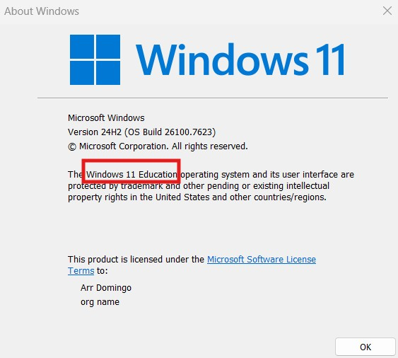
Figure 5. Upgraded to Windows 11 Education to enable Hyper-V.
- Go to Windows and search for “Turn Windows features on or off”.
- A window will show up, enable “Hyper-V” and “Virtual Machine Platform”.
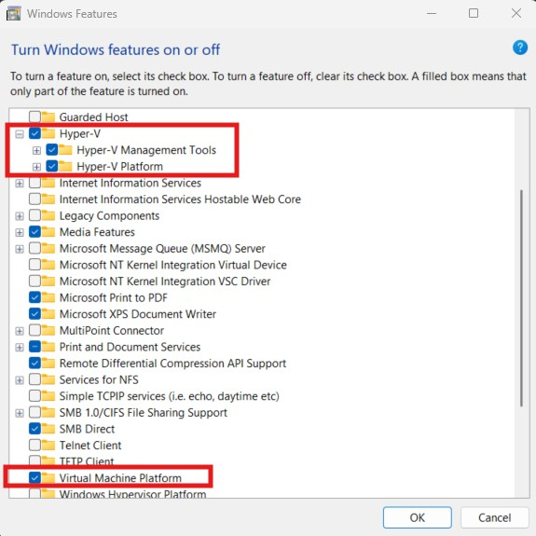
Figure 6. Enable Windows features.
- Click OK and it will ask to restart your computer. After restarting, Hyper-V is now ready to use.

3.3 Create Virtual Machine in Hyper-V Manager
- Go to Windows, search “Hyper-V Manager” and click on it.
- Hyper-V window will appear. The left panel shows the available machines.
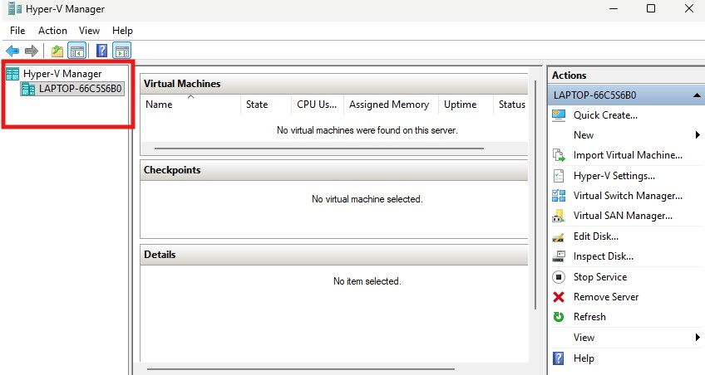
Figure 7. Hyper-V Manager window.
- To build a machine for this lab, go to the left panel and right click on your machine > New > Virtual Machine.
- “New Virtual Machine Wizard” window will appear. Click Next on “Before You Begin”.
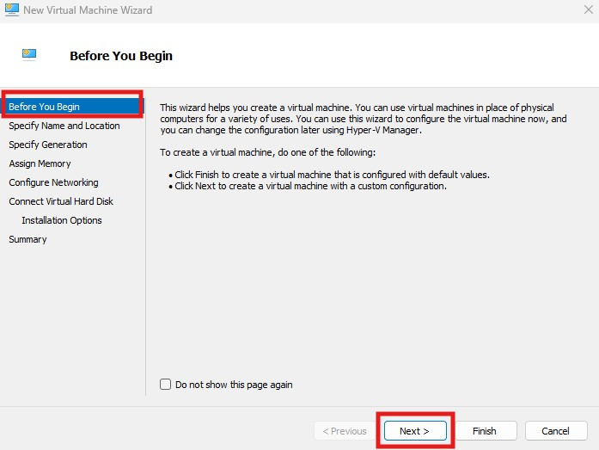
Figure 8. Creating new virtual machine in Hyper-V Manager.
- Name the newly created virtual machine after your NAIT username. Click Next.
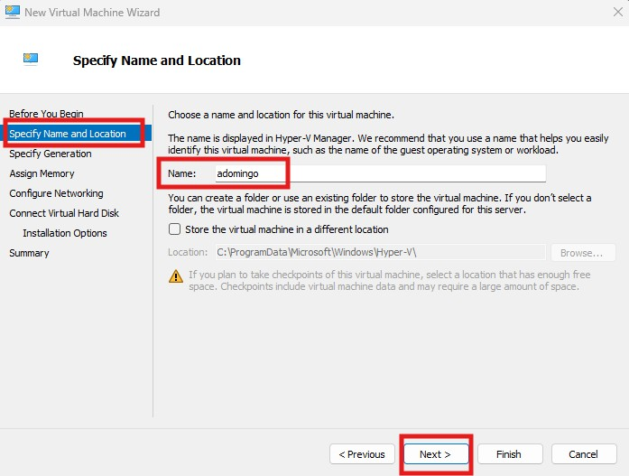
Figure 9. Name of the virtual machine.
- Choose “Generation 2” and click Next.
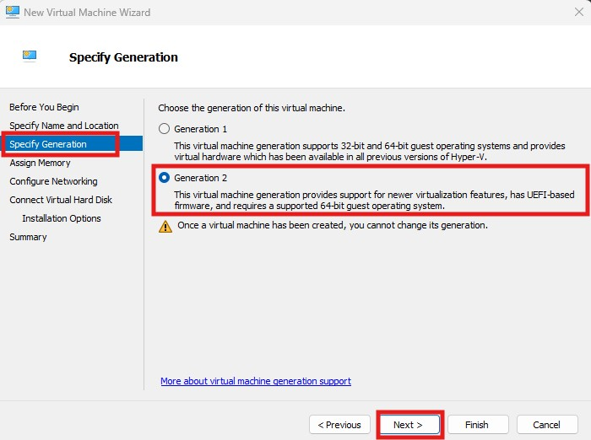
Figure 10. Choose Generation 2.
- Enter 16,000 MB (16 GB) in the Startup memory and make sure to enable “Use Dynamic Memory for this virtual machine”. Click Next.
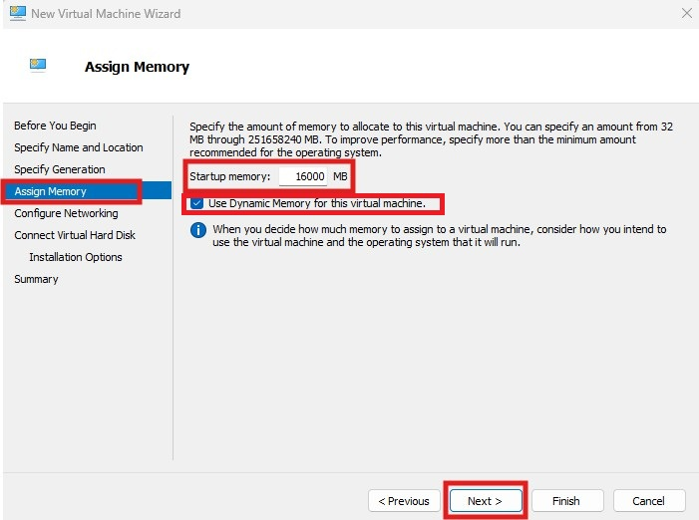
Figure 11. Set the memory.
- On Configure Networking, set the connection to “Not Connected” for now. Click Next.
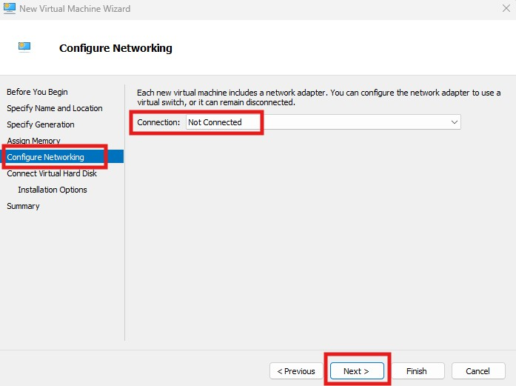
Figure 12. Configure networking must be set to Not Connected.
- On “Connect Virtual Hard Disk”, choose “Use an existing virtual hard disk”.
- Click on Browse and go to where you saved the extracted VHDX file. Click Next.
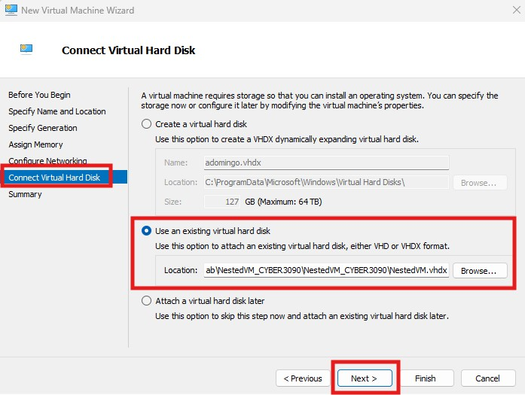
Figure 13. Connecting to the extracted VHDX file.
- Click Finish.

3.4 Enable nested virtualization
To be able to run a virtual machine inside a virtual machine or commonly known as nested virtualization in Hyper-V, follow below instructions:
- Go to Windows and look for “Command Prompt” or “Windows PowerShell”. Right click and choose “Run as administrator”.
- Run the command:
Set-VMProcessor -VMName "<VMName>" -ExposeVirtualizationExtensions $true
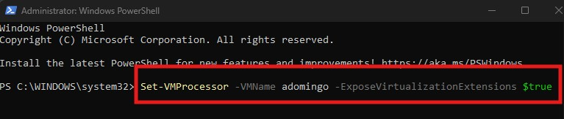
Figure 14. Command for nested virtualization.

3.5 Start the new virtual machine
- Highlight the new virtual machine and click “Connect”.
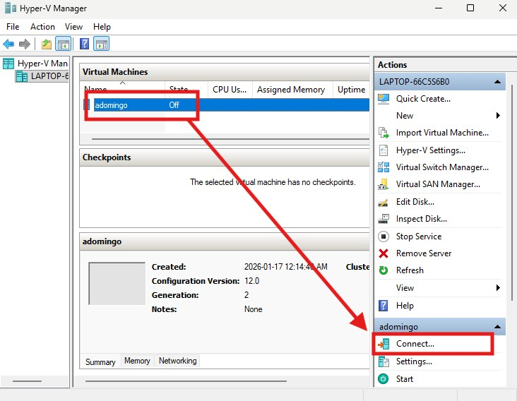
Figure 15. Connect the new virtual machine.
- A window will appear, click Start.
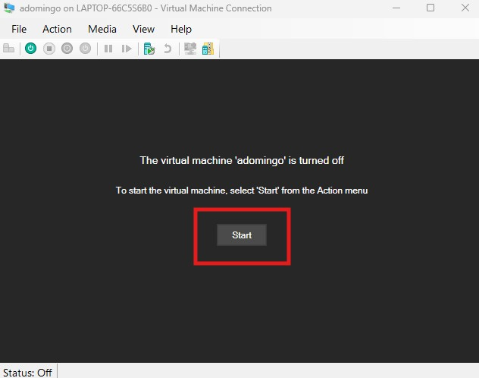
Figure 16. Start the new virtual machine.

References
There are no sources in the current document.

